EXP 7 – ORDER BY ,GROUP BY
- ORDER BY ASCENDING
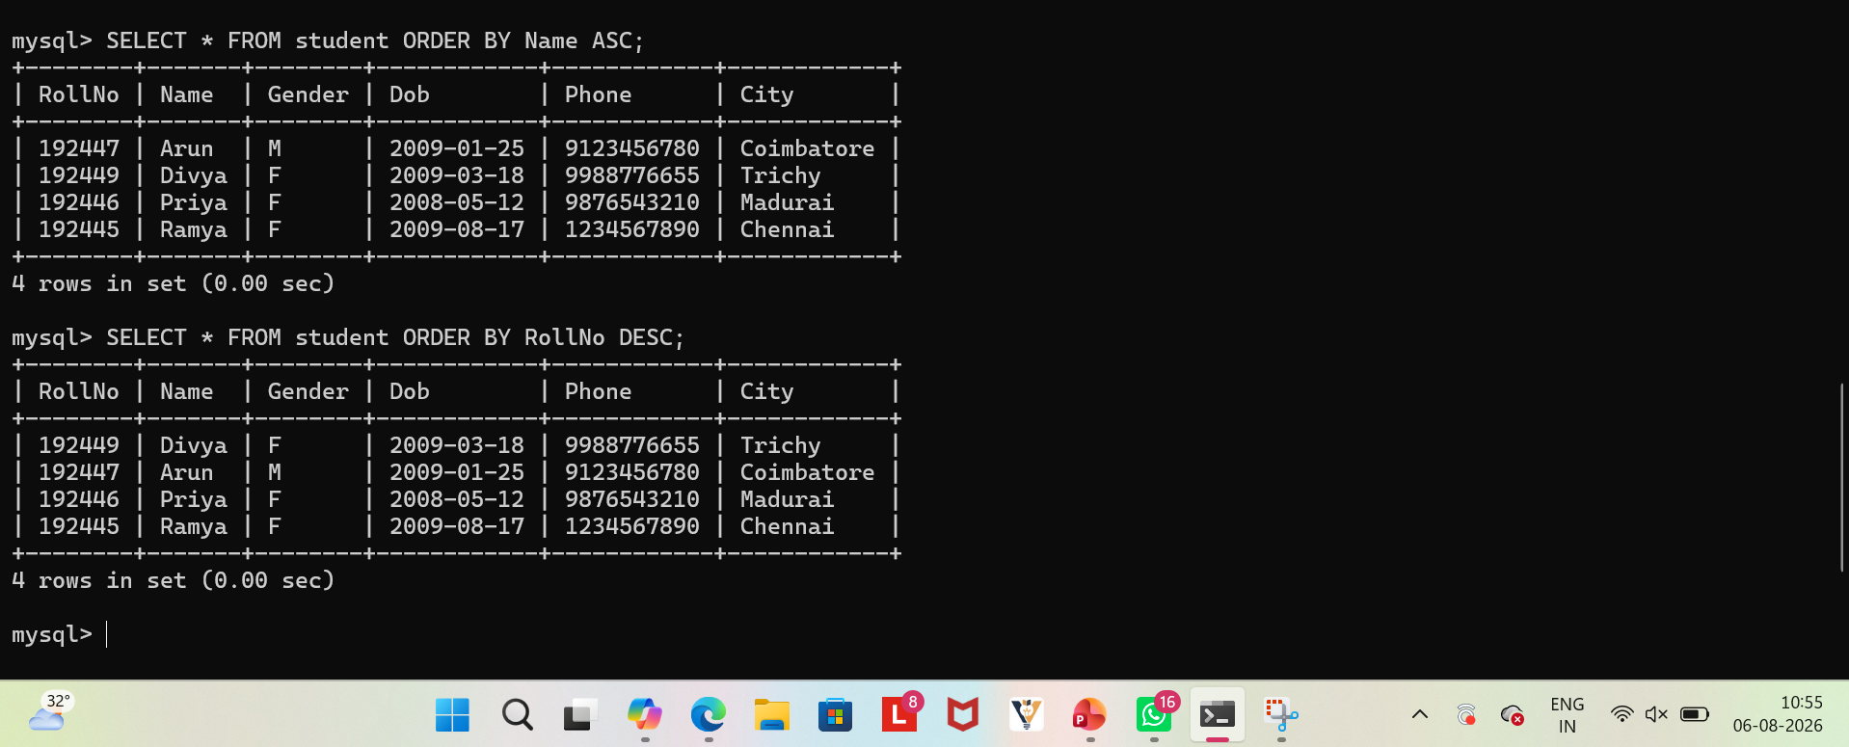
- ORDER BY DESCENDING
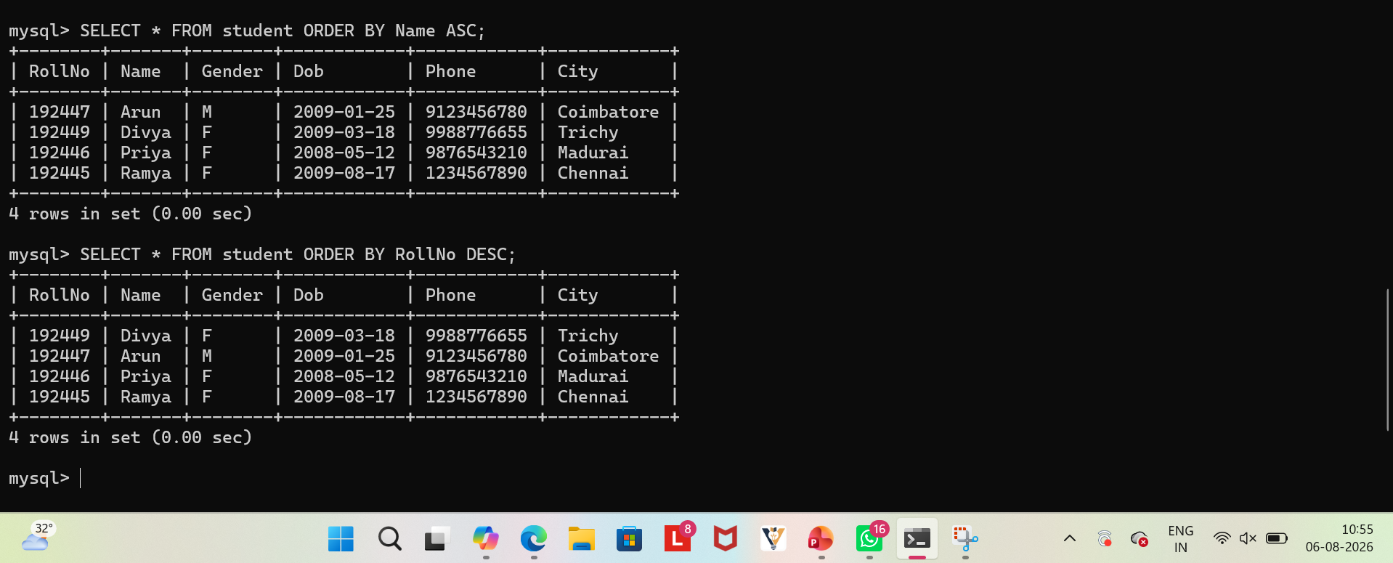
- GROUP BY CITY
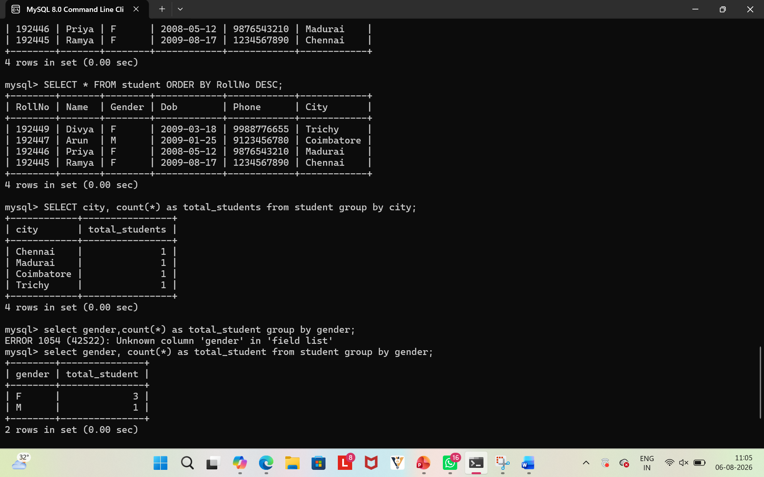

- GROUP BY GENDER

- GROUP BY CITY WITH ORDER BY TOTAL STUDENTS
